**Raspberry Pi Serial port communicates with external devices**

The Raspberry Pi possess two serial ports available, the hardware serial port (/ dev / ttyAMA0) and the mini serial port (/ dev / ttyS0). The hardware serial port has a separate baud rate clock source with good performance and better stability. The mini serial port with simple functions and poor stability, the baud rate is provided by the CPU core clock, which is affected by the core clock.

The Raspberry Pi (3B/B+/4B) has an on-board Bluetooth. The default hardware serial port is assigned to the Bluetooth module, and the mini serial port is assigned to the GPIO serial ports( TXD0/RXD0).

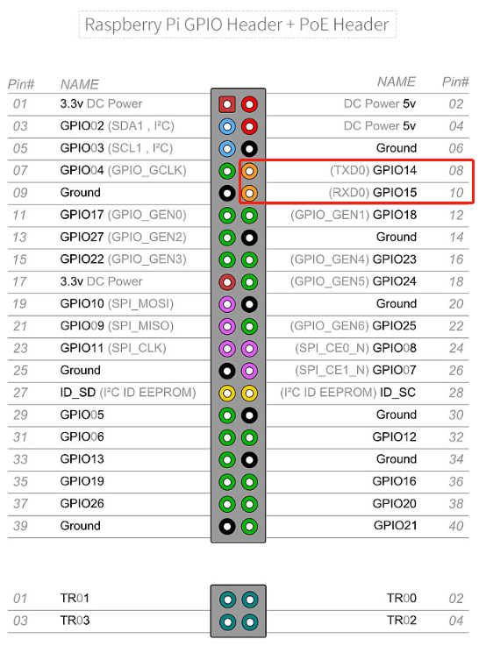

Run the following command to view the default serial port allocation method:

ls /dev -al

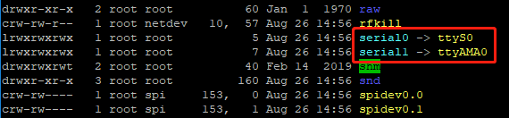

Since the hardware serial port is assigned to the on board Bluetooth by default, we will release it and assign the hardware serial port to the GPIO serial port.

1.After we enter the Raspberry Pi system by SSH, we need to input following command.

sudo raspi-config

Enter the Raspberry Pi system configuration interface and select the fifth 【Interfacing Options】 as shown below.

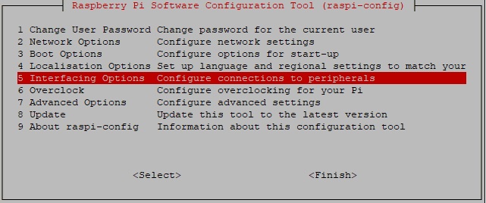

Select 【P6 Serial】

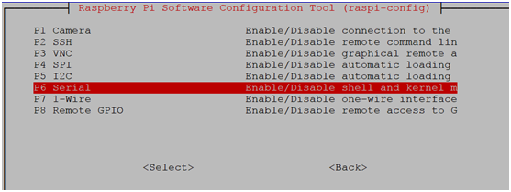

Select to close the serial port login function and enable the hardware serial port debugging function.

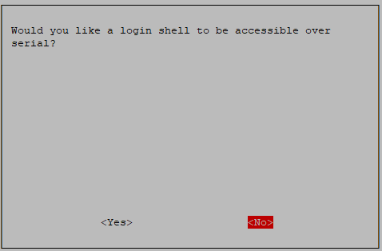

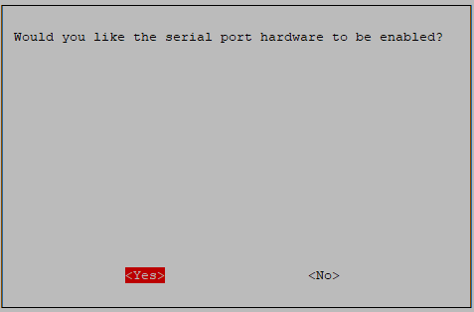

After the completion, Raspberry Pi interface will prompt following interface. Press”OK”.

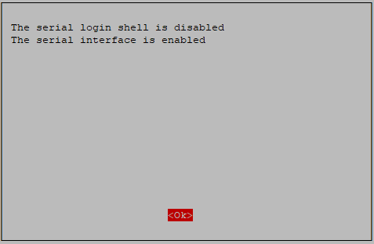

Exit the raspi-config settings and restart the Raspberry Pi as prompted.

**2.Set hardware serial port as GPIO serial port**

Edit /boot config.txt file the directory.

sudo nano /boot/config.txt

Add the following two lines command to the end of the file.

dtoverlay=pi3-miniuart-bt

force_turbo=1

As shown below.

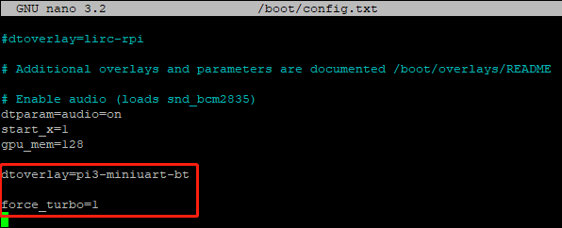

Save: Ctrl+O

Exit: Ctrl+X

Input following command to restart Raspberry Pi

sudo reboot

After restart is complete, input ls /dev -al, we can see the two serial ports have changed positions. As shown below.

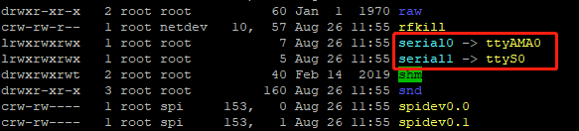

**3.mini com serial port test**

Input following command to install minicom

sudo apt-get install minicom

After installation is complete, we can input following command to start minicom

minicom -D /dev/ttyAMA0 -b 9600

-D indicates that the serial port /dev/ttyAMA0 is selected, and -b sets the baud rate to 9600. (This parameter didn’t need to be set. The default is 115200.)

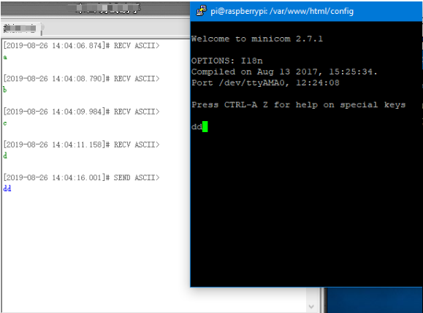

After serial port is opened, we can transfer data by USB to TTL module.

**Exit minicom steps:**

First, press “Ctrl+A”, then press “Z”, you can see following menu.

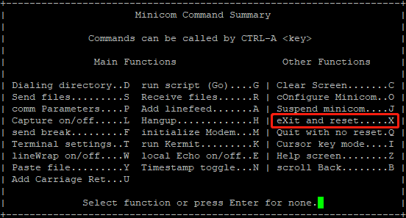

Next, press “X”. Finally, select “YES” and press “Enter” key.

USB to TTL module connect to Raspberry Pi.

|  |  |
| --- | --- |
| **Raspberry Pi** | **USB to TTL module** |
| 5v | VCC |
| GND | GND |
| RXD0 | RXD |
| TXD0 | TXD |

**4.C language reference code, print hello world!**

#include <stdio.h>

#include <wiringPi.h>

#include <wiringSerial.h>

int main()

{

    int fd;

    if(wiringPiSetup() < 0)return 1;

    if((fd = serialOpen("/dev/ttyAMA0",9600)) < 0)return 1;

    printf("serial test start ...n");

    serialPrintf(fd,"Hello World!!!n");

    while(1)

    {

        serialPutchar(fd,serialGetchar(fd));

    }

    serialClose(fd);

    return 0;

}

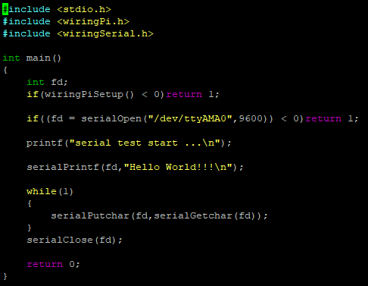

Input following command to new create testCom.c file

nano testCom.c

Copy above code into testCom.c file.

Save: Ctrl+O

Exit: Ctrl+X

Input following command to compile this program.

gcc testCom.c -o test -lwiringPi

Input following command to run code

./test

1566802330211888.png

You can send data to the Raspberry Pi by serial port, the Raspberry Pi will directly return to the serial port for display.

Note: If garbled characters are displayed, please check the baud rate. It needs to be set to 9600(the same as program).